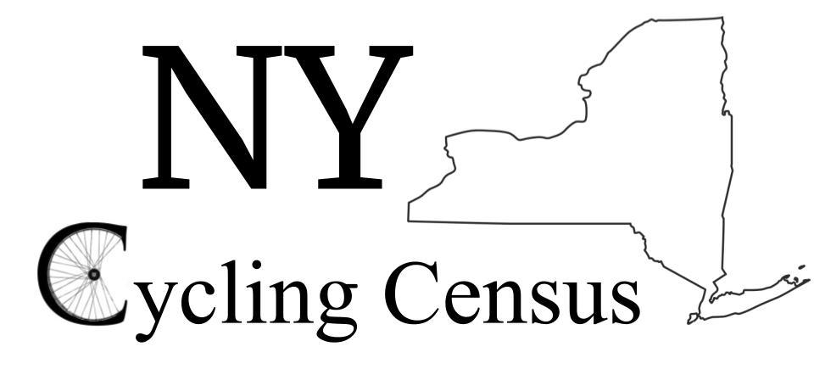

Survey Link

https://nyserda.az1.qualtrics.com/jfe/form/SV_aaOKnyxZSgkskmi

Newsletter Text

Be a part of the first New York State Bike Census! This is an exciting and unprecedented opportunity to help shape the future of cycling and document where, why and how New Yorkers are riding bikes! With this survey information, we can help shape public policy that will foster safer streets, and more equitable transportation options across the state.

Administered by Urban Cycling Solutions (UCS), the Cycling Census will collect a statewide dataset on bicycle integration with mass transit. The purpose of this short survey is to collect insights from cyclists and transit customers from all over New York State to better understand opportunities and barriers for active first/last mile transportation. This survey is supported by the New York State Energy Research and Development Authority (NYSERDA).

Please help direct the future of more and safer bicycling in New York, by completing and submitting to the New York Bike Census! Each participant will be entered to win one of three $150 Planet Bike gift cards offered by UCS.

The data gleaned from this survey will be used to help shape the future of bicycling in New York, and assist decision makers in developing a more inclusive and equitable multimodal transportation system. Please be assured your email addresses and other personal information will not be saved or shared!

