Reno Bike Project – Mechanic Educator

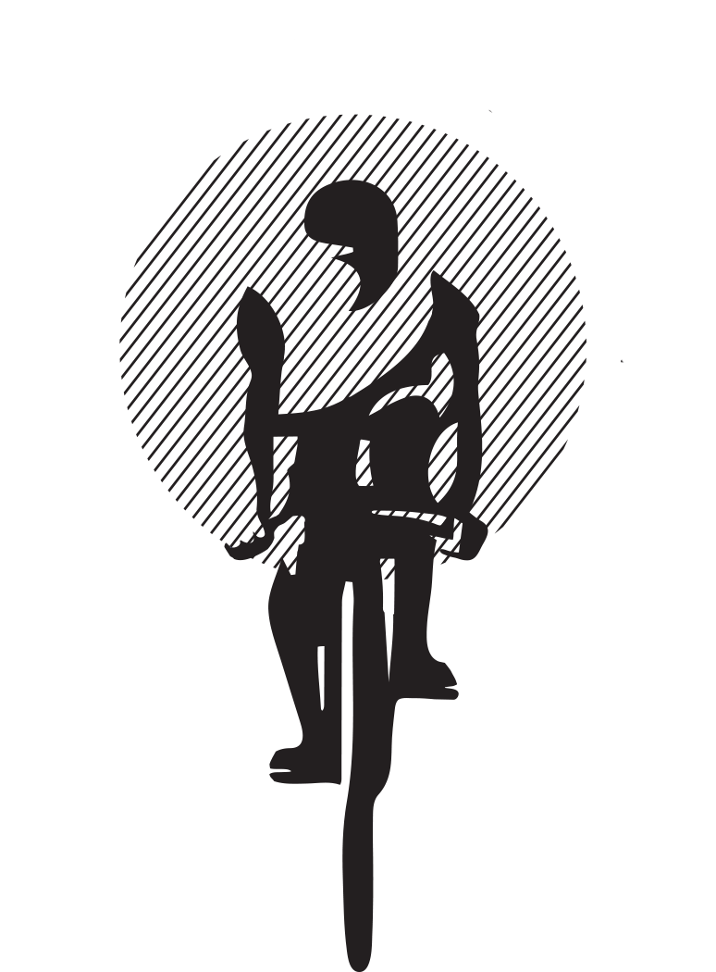
Position Description: RBP is seeking an experienced bicycle mechanic who can teach bike maintenance and repair as well as perform a wide range of shop activities. This is not your typical mechanic position, nor a typical shop. You will assist with a wide scope of activities and will be required to wear many different hats in a fast-paced work environment. Our shop serves bicycle hobbyists, college students, Reno’s homeless population, and others. We repair their bicycles, answer questions, and provide excellent customer service to all. Repairs on customers’ bikes represent us as a bike shop, so any repair must be completed to the best of your ability and the highest standards. We repair bikes of all varieties and ages.
Aside from operating a full-service repair department, our organization is committed to helping people learn bicycle repair/maintenance in our public workstations, where the public can utilize our tools and knowledge in order to repair their own bikes. People from all walks of life and skill levels use our shop and sometimes that can be a challenge. Patience and a good attitude are mandatory attributes. If you enjoy helping people one-on-one, and want to help provide our community with a valuable resource, this might be the job for you. Working at Reno Bike Project is an opportunity to join a close-knit group of motivated individuals who, daily, make a substantial impact on the cycling community in Reno by educating and encouraging cyclists to be self-reliant, motivated, and knowledgeable.

Duties & Responsibilities:
The following reflects management's definition of essential functions for this job but does not restrict the tasks that may be assigned. Management may assign or reassign duties and responsibilities at any time in order to provide reasonable accommodation or for other reasons.
- Perform bicycle repair, maintenance, and diagnostic services on customers' bicycles on a walk-in basis;
- Deliver professional, accessible, and helpful customer service to a diverse customer base;
- Support daily bike shop operations;
- Process service work including correctly filling out service work orders, scheduling an appropriate amount of repairs and completing those repairs in a timely manner;
- Advise and assist customers with their product selection without bias;
- Develop and maintain knowledge and expertise of all merchandise in the shop to effectively assist customers with accurate information;
- Assist with bike sales and any other shop floor duties as needed;
- Maintain a clean and safe workplace;
- Help with shop maintenance and construction projects; and
- Perform other duties as assigned by the bike shop manager.

Compensation: DOE

Schedule: 25-40 hours/week

Qualifications:
- Excellent bicycle repair skills, or a desire to develop existing skills;
- Strong customer service skills;
- Spanish fluency or proficiency highly desirable;
- A self-directed, energetic, flexible, and personable attitude;
- Excellent organizational skills;
- The ability to work both independently and as part of a team; and
- The ability to multi-task in a fast paced environment and the ability to work some weekends and holidays to support business needs.

To Apply: Qualified & interested applicants, please submit a resume to noah@renobikeproject.com, or in person at 216 E Grove Street.

About the Organization:
Reno Bike Project (RBP) is a 501(c)(3) non-profit community bicycle shop and resource for the Truckee Meadows committed to creating a nationally recognized, cycling-friendly community through education, cooperation and advocacy. We achieve our mission by:
- Making cycling more accessible to the public through recycling and recirculation of used bikes into the community at affordable prices.
- Encouraging self-sufficiency by holding bike mechanics workshops and by providing a space for community members to repair their own bicycles rather than incur maintenance costs.
- Encouraging bicycle activism by promoting and producing cycling related events for a variety of audiences.
- Advocating for cycling rights and cycling growth in the Truckee Meadows by working with public officials and other organizations that are key players in transportation planning.
- Complementing other local groups to encourage youth safety and cycling-related arts and culture, and contributing to Reno’s continual growth as a diverse and vibrant community.
- Keeping an open mind to all cycling needs and ideas and helping to facilitate positive growth.

Our goal is to be a diverse and inclusive workforce that is representative, at all job levels, of the community we serve. This position is available to all, without regard to race, color, national origin, disability, age, sex, gender, sexual orientation, political affiliation, religion, or any other status protected under the law.

