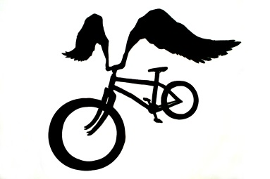
Bicycle Safety and Maintenance Questionnaire

I think I can: | Definitely Not | Maybe | Easily
- Adjust my helmet | 1 2 | 3 4 | 5
- Use the correct hand signals while biking | 1 2 | 3 4 | 5
- Ride a bike safely on the street with cars | 1 2 | 3 4 | 5
- Lock my bike securely | 1 2 | 3 4 | 5
- Figure out if something is wrong with my bike | 1 2 | 3 4 | 5
- Use a map to choose a safe bike route | 1 2 | 3 4 | 5
- Merge to make a left hand turn | 1 2 | 3 4 | 5
- Ride my bike in all kinds of weather | 1 2 | 3 4 | 5
- Ride my bike places I want to go | 1 2 | 3 4 | 5

